Order Of Service

Singing: Psalm 31—CW page 77

Reading: Psalm 106:32-39

Opening Hymn: TLH 31

Reading: Acts 24:10-21

Request Hymn: CW Supplement 735

Reading: Matthew 10:40-42

Sermon Hymn: TLH 366 vs 1-4

Sermon Text: Mark 10:17-22

Lacking One thing

Prayer

The Apostles’ Creed, TLH page 12

Holy Communion

The Lord's Prayer

The Blessing

Closing Hymn: TLH 366 vs 5-7

* * * * * * * * * * *

Bible Study: Lambs: Hognose Snake
Sheep: Proverbs 20:21-25
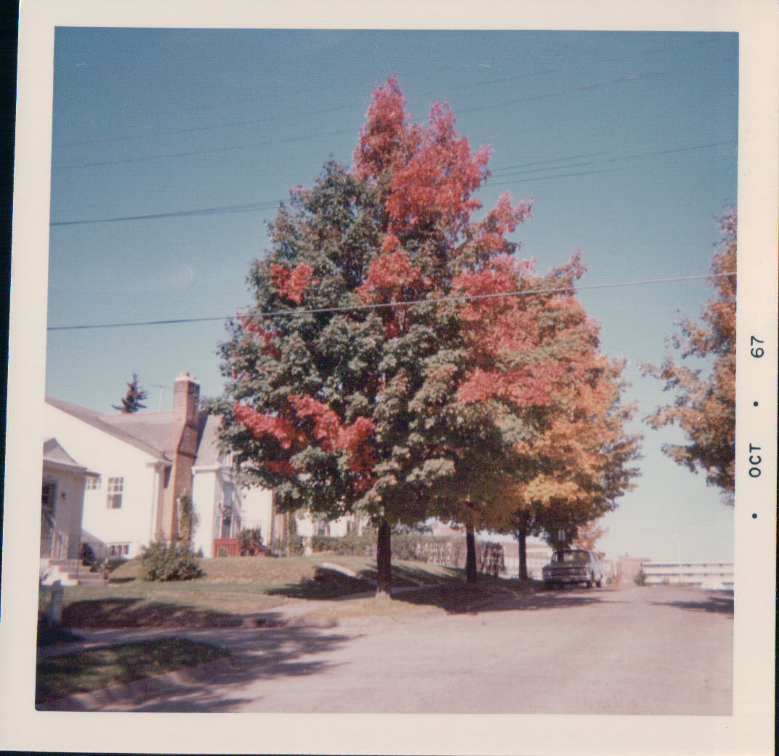

First Sign Of Fall—Duluth, MN

Water
Of
Life

20 October 2019

W A T E R O F L I F E

Independent Christian Church—Conservative Lutheran Doctrine

Worship Service: 9:30 a.m. Bible Study: 10:45 a.m.

Larry Cooper, Pastor E-Mail address:
111 N. Ridge Road lcooper@wateroflife.cc
Coon Valley, WI 54623 Web Site:
www.wateroflife.cc

* * * * * * * * * * * * * * * * * * * * * * * * * * *

Sermon Text: Mark 10:17-22

Lacking One Thing

* * * * * * * * * * * * * * * * * * * * * * * * * * *

Mark 10:17 And when he was gone forth into the way, there came one running, and kneeled to him, and asked him, Good Master, what shall I do that I may inherit eternal life?
:18 And Jesus said unto him, Why callest thou me good? there is none good but one, that is, God.
:19 Thou knowest the commandments, Do not commit adultery, Do not kill, Do not steal, Do not bear false witness, Defraud not, Honour thy father and mother.
:20 And he answered and said unto him, Master, all these have I observed from my youth.
:21 Then Jesus beholding him loved him, and said unto him, One thing thou lackest: go thy way, sell whatsoever thou hast, and give to the poor, and thou shalt have treasure in heaven: and come, take up the cross, and follow me.
:22 And he was sad at that saying, and went away grieved: for he had great possessions.

Matthew 6:24-34

24 No man can serve two masters: for either he will hate the one, and love the other; or else he will hold to the one, and despise the other. Ye cannot serve God and mammon.
25 Therefore I say unto you, Take no thought for your life, what ye shall eat, or what ye shall drink; nor yet for your body, what ye shall put on. Is not the life more than meat, and the body than raiment?
26 Behold the fowls of the air: for they sow not, neither do they reap, nor gather into barns; yet your heavenly Father feedeth them. Are ye not much better than they?
27 Which of you by taking thought can add one cubit unto his stature?
28 And why take ye thought for raiment? Consider the lilies of the field, how they grow; they toil not, neither do they spin:
29 And yet I say unto you, That even Solomon in all his glory was not arrayed like one of these.
30 Wherefore, if God so clothe the grass of the field, which to day is, and to morrow is cast into the oven, shall he not much more clothe you, O ye of little faith?
31 Therefore take no thought, saying, What shall we eat? or, What shall we drink? or, Wherewithal shall we be clothed?
32 (For after all these things do the Gentiles seek:) for your heavenly Father knoweth that ye have need of all these things.
33 But seek ye first the kingdom of God, and his righteousness; and all these things shall be added unto you.
34 Take therefore no thought for the morrow: for the morrow shall take thought for the things of itself. Sufficient unto the day is the evil thereof.

